EX:2.1
VLAN CONFIGURATION

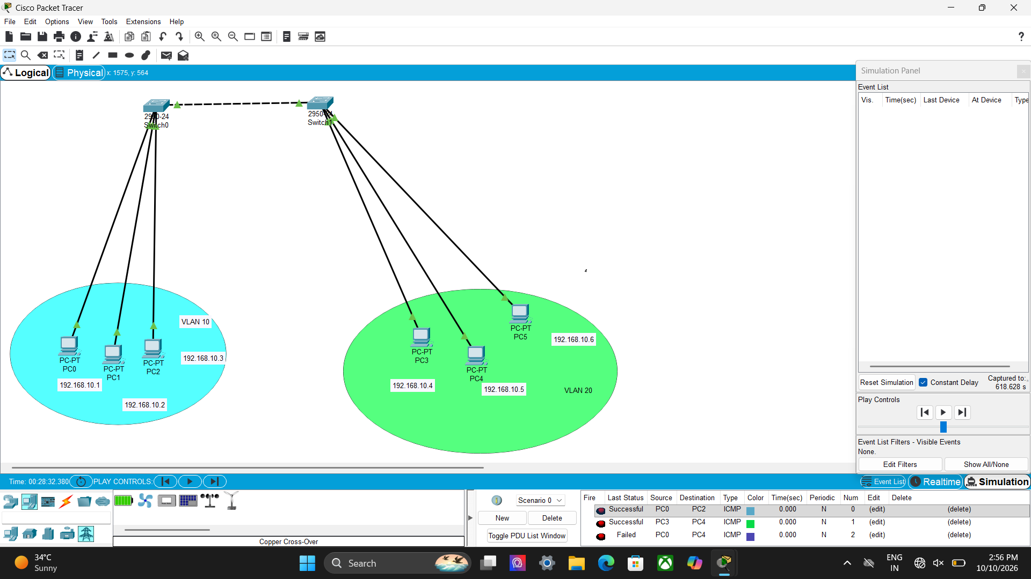

EX:2.2

INTER – VLAN CONFIGURATION

